Crazy Donut

Objective: For the class to work together to keep the “crazy donut” moving.

Background:

Formerly known as “Jump the Shot,” it became known as “Crazy Donut” because of a humorous comment a student once made during the activity.

Originally, this was an elimination game. That meant in a class of 20 students, the first student eliminated had to watch 19 more rounds without participating! – Not being best practice, the game was immediately modified!

Equipment:

- Boom Box
- Music - Upbeat
- Crazy Donut – Use a dek ring tied to a jump rope; preferably a segmented jump rope (see picture below)

Setup:

- Students stand in a circle (If you have a painted circle, 15-25 feet in diameter in your gym, have students stand on the line.)
- Teacher or designated “spinner” stands in the middle

Description:

- When the music begins, the “spinner” turns the rope so the donut moves around the circle in a counter clock-wise direction. The donut should be touching the line that forms the circle. (For most people, it is much easier to spin counter clock-wise.)

- As the donut passes by each student, each one jumps over the donut

- Count the number of times the “crazy donut” successfully makes a full rotation
- If it hits a student’s foot or ankle, start the count over.
- How many times can the donut go completely around the circle without stopping? Try to have students improve on the number of successful rotations each time.

Helpful Hints:

- Do not let students stand too close together.
- Make sure each student stays on the line and does not start working his/her way forward into the circle. This blocks the view of other students standing near him/her.

Variations:

- Spin the donut clockwise

- Divide into two groups – The groups would alternate each time there is a miss. See which group can get the most successful rotations before the crazy donut stops.

- Double Donut – Have two circles going (if you have 2 capable spinners). If a student gets hit by the donut in one circle, he/she goes to the other one.

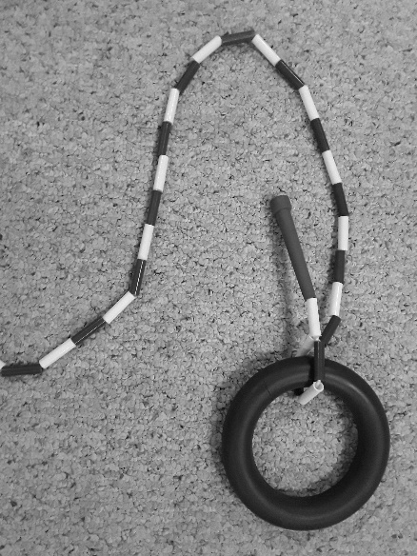
Dek ring with segmented jump rope

