3 Ring Circus Grades 1-6

The students are the performers and the teacher is the ringmaster!

Introduction: In my gym, I had two circles about 20-25 foot in diameter that I use for 2 of the rings. The third ring, although not visible, goes around the other two rings (see diagram below). If you don’t have two circles in your gym, just make them using cones.

Equipment & Setup:

- Divide the class into 3 groups

- Put one group in each circle

- Assign different exercises to be performed in the middle two circles

- Assign a locomotor skill to be performed on the outside ring. Make sure students know what direction they will be moving…clockwise or counter clockwise.

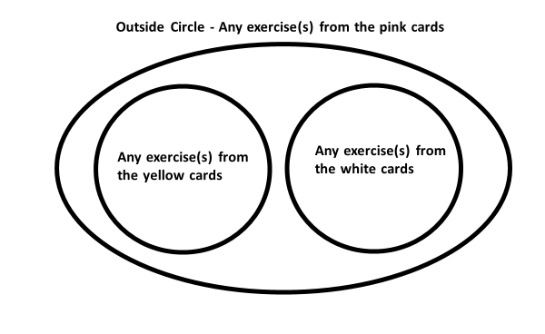

This diagram illustrates using the Word Wall that is mentioned below under “variations.”

When the music begins –

- All three groups perform their assigned exercises or locomotor skill

- After a minute, have students switch rings to do a different exercise

- After another minute, have students go to the ring where they have not been.

- Second and Third Rounds – Assign different exercises and locomotor skill.

Helpful Hints:

- Make sure each student stays within their designated rings.

- Students performing the locomotor skill should not be moving between the two inside rings unless you allow it. (I sometimes allow it on the third round.)

- Student moving around the outside circle should not be cutting through the two inside rings.

- If you have calliope* music to play, it enhances the circus atmosphere.

Variations:

- I have a Word Wall setup in my gym (see “Word Wall”). I usually use this for the exercises. Once students know which category they are using in each ring, they can make their own choices from the list. They can also switch to another exercise in the same category while they are in a ring. (The diagram illustrates using the Word Wall.)

- This activity can also be used to practice skills. For example, one of the inside circles could be jumping rope, the other inside circle could be practicing bean bag-related skills such as juggling, and the outside ring could be moving while dribbling a ball.

* A calliope is a musical instrument that produces sound by sending steam through large whistle pipes.

