Word Wall

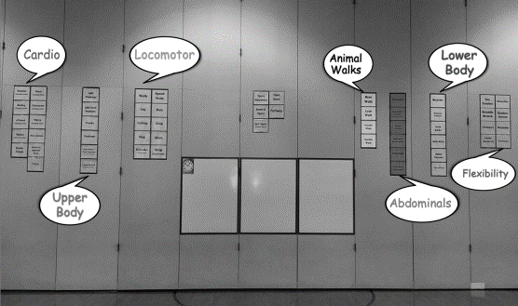

Word Wall as setup on the gym divider

Background

In my gym, I installed what I call a “Word Wall.” I wanted students to consider them as vocabulary words where they had to recognize, spell, know the meaning of, and categorize them.

Categories

The exercises were placed into one of seven categories with each category having its own color. The categories and colors were as follows:

1.) Abdominals ------------------------ Gold
2.) Animal Walks ---------------------- White
3.) Cardio -------------------------------- Blue
4.) Flexibility --------------------------- Green
5.) Locomotor-------------------------- Pink
6.) Lower Body ------------------------ Gray
7.) Upper Body ------------------------ Yellow

Advantages
The Word Wall was integrated into many warmups, games and activities throughout the school year. Some of the things I particularly liked about the Word Wall:

1.) It was readily available for use and was visible from almost every part of the gym.

2.) It gave students choices. For example, instead of the instructor saying, “do pushups,” each student had the opportunity to choose which exercise they would prefer as long it was in the same category as pushups. In this case the category was “upper body.”

3.) Students became familiar with the categories and why the exercises were classified the way they were.
4.) Students learned the muscles that each exercise would affect.

5.) Students learned to recognize each word, learned the exercise that the word represented, and how to properly perform each exercise.

6.) Students eventually learned how to pronounce and spell each exercise.

7.) By letting them make choices, it gave students more independence.

Constructing the Word Wall

I typed the words in large font on my laptop, printed them, then ran them through the laminator so they were on long strip (much easier to hang). Where you see a double row, such as the cardio, that is 2 separate long strips hanging side-by-side.

The words were fastened to the wall using duct tape by looping a piece of tape and placing it on the back of the strip. It was strong enough to hold the words up all year. I strategically placed them on our divider wall so that opening and closing the door did not damage any of the words.

Never have anyone do for you what you can do for yourself ~ Th. Jefferson

