Dizzy Dominoes Grades 2-6

This can be used as a warm-up or as the main activity in a fitness lesson.

Equipment:

- 4 small hula hoops, large polyspots or placemats from the dollar store
- dominoes – enough to place 20-25 in each hoop (use 6 base dominoes where 6 is the highest number on one half of the domino. – (There are other bases.)
- 4-6 exercise charts – posted on gym walls
- equipment needed to perform the exercises (if any)

Setup:

- Divide the class into 4 groups of 4-5 students.
- Each group has a small hula hoop – placed as in the diagram below
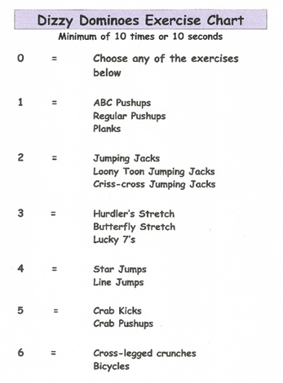
- The dominoes are divided equally among the four hoops and placed face down in each team’s hoop.
- The Exercise Charts are posted so there is
at least one on each wall of the gym.

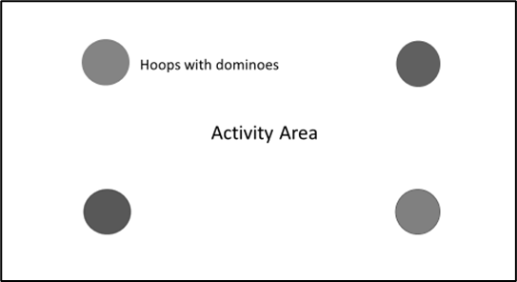

Description:

When the music begins -

- Each student selects a domino from his/her group’s hoop then subtracts the smaller number from the larger number to get the answer.

- The student moves to one of the exercise charts to find the exercise that corresponds with the answer.

- Next, he/she moves to the center “activity area”, and performs that exercise.

- Once the exercise is completed, the player places the domino in another group’s hoop facedown. Have them place it at the hoop where there are the fewest dominos.

- The student goes back to his/her group, selects another domino and repeats the process.

- Often, we go for 10-15 minutes.

Helpful Hints:

- This was originally a competitive activity where the objective was to have no dominoes left in your team’s hoop. However, when played this way, the competitiveness results in the quality of the exercises being sacrificed.

- I usually do it non-competitively. If a hoop is running out of dominoes, I move some dominoes from the hoops with a lot them while the activity is going on.

- Remind students that they are performing their exercises in the middle.

Variations:

- Change the exercises, skills or activities that are used.

- Make a list of 2-3 exercises or skills under each number and let students choose which one they want to do. (*The above chart depicts this option.)

- Add the dominoes instead of subtracting. However, the exercise chart will need a different chart.

- Use 9-based dominoes (where each half of the domino goes up to 9)

