Six Little Turtles

Setup | Objective | Standards & Outcomes:

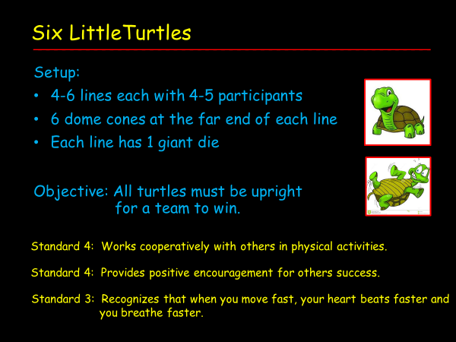

- The 6 dome cones at the far end of the line are upside-down like turtles on their shells.

- The cones are numbered 1 through 6 starting from the left-hand side.

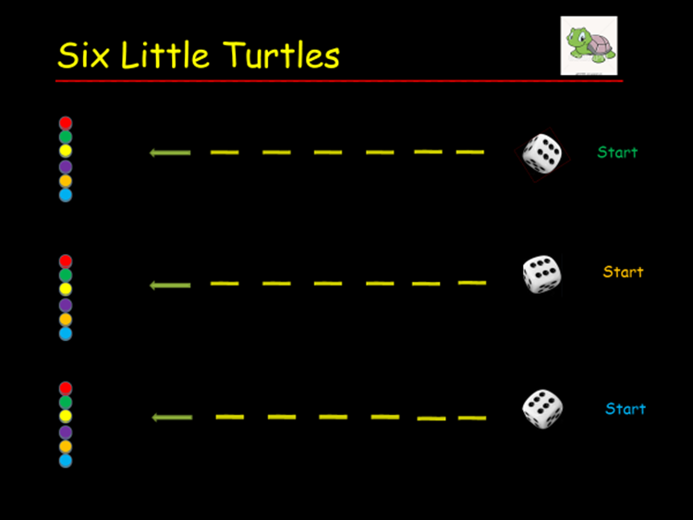

Description:

- At the staring signal, the first person in line rolls the die then runs to the far side where the turtles
belonging to that group are upside down.

- The player turns over the dome cone that matches the number on the die he/she just rolled.
For example: If a 3 is rolled, the 3rd cone from the left will be turned over.

- The player returns to his/her line and goes to the back to await his/her next turn.

- The second player rolls the die then runs to the far side to turn over the corresponding numbered
turtle.

- The players on each team continue to take turns until all of their turtles are right-side up.

- Please note: If the same number is rolled by another player, that player still flips the dome cone
even if it means returning the turtle to its back.

Note: Some participants are concerned that the odds are not very good on getting all the turtles upright in a reasonable amount of time. I have rarely experienced a situation where a group was unable to get all 6 turtles right-side up. However, if the activity goes too long, simply stop the game and the team(s) with the most turtles standing would be the first-place finishers.

6 Little Turtles

