13 Hoops

Background: The original activity was named “13 Hoops” because it used 13 hula hoops setup as in the diagram below. Since then, I have found that polyspots work much better. The number of polyspots needed will depend on the size of your class. You will need a polyspot and object for every two students.

Setup | PA Standards & Outcomes:

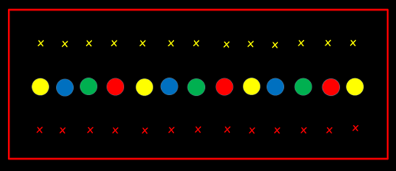
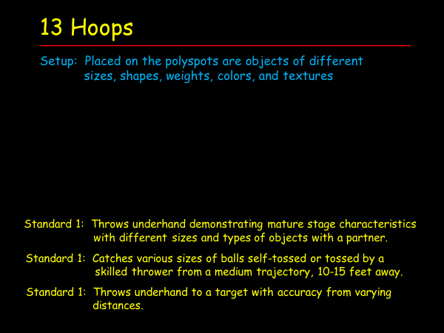

- There should be two students facing each other on opposite sides of each polyspot. They should be 3-5
steps back from the polyspot (so there are approximately 6-10 steps between them). The two students
will share the object on the polyspot once the activity begins.

Description – This is using the first and second standards and outcomes listed above.

- When the music begins, the two students will practice their underhand throwing and catching skills by
tossing the object back and forth. Both should be trying to give his/her partner a good throw so that it
can be caught.

- After a set amount of time (1-2 minutes) the music stops and the object is returned to the polyspot.

- The students rotate so they get a different partner and a different object.

- When the music begins, the two students will practice their underhand throwing and catching skills by
tossing the object back and forth just as they did with their previous partners.

- This rotation and activity continues until all students have had an opportunity to use every object.

- Suggestion: Specify which side picks up the object prior to starting each round. This prevents students
from running toward their polyspot at the same time and possibly colliding.

Rotation: Facing their partners, each student moves to the polyspot on his/her right. The player on each side of the polyspots, who is displaced, moves to the other end of the line on the same side.

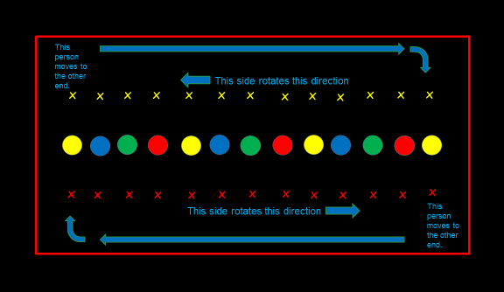

Description: This incorporates the third standard and outcome listed above that pertains to “accuracy from varying distances.” - Everything is the same as in the previous description except for the following:

- After 3 consecutive successful throws and catches, have the student who caught the third throw move
back a giant step to increase the distance between partners.

- The students continue until they complete another 3 consecutive throws and catches from this new
distance.

- Once again, the student who makes the third catch takes a giant step backwards. (By using an odd
number of catches, the chance of each person getting to step backwards increases.)

- If the object is dropped at any time, the partners start over, staying where they are, and continuing to
try to get 3 consecutive throws and catches.

Variations:
- Change the number of consecutive throws and catches it takes before one student moves backwards.

- After 3 consecutive throws and catches, have both take a step backwards.

- If the object is dropped, the person who did not catch it moves forward one giant step.

- If the object is dropped, both students go all the way back to where they originally started.

13 Hoops – Throwing and Catching

